wazuh.
Ransomware Detection Lab
Setup, Configuration & Testing Guide

Wazuh All-in-One | Ubuntu 24.04 LTS Agent
Real-time FIM · Auditd · Active Response · Simulation Testing
Version 2.0 · June 2026

Table of Contents

1. Lab Environment Overview 2
2. IP Variables Reference 2
3. Wazuh Agent Installation 3
4. FIM — File Integrity Monitoring 4
5. Auditd Syscall Monitoring 5
6. Custom Detection Rules 6
7. Active Response Configuration 7
8. Ransomware Simulation & Testing 8
9. Real-time Alert Monitoring 9
10. Troubleshooting Reference 10

1. Lab Environment Overview
This guide documents a complete Wazuh ransomware detection lab using an all-in-one Wazuh server and an Ubuntu 24.04 LTS agent. Every configuration step, detection rule, and test procedure is covered from initial setup through real-time alert verification.

Component | Role | OS / Version
Wazuh All-in-One | Manager + Indexer + Dashboard | Ubuntu 22.04 LTS
Ubuntu Agent | Monitored endpoint | Ubuntu 24.04 LTS
FIM (syscheck) | File change detection | Built-in Wazuh
Auditd | Syscall-level monitoring | Linux kernel audit
Active Response | Auto-containment | Built-in Wazuh

2. IP Variables Reference
All configuration examples in this document use placeholder variables. Replace every value in angle brackets with your actual environment values before applying to a live system.

TIP | Replace ALL < > placeholders with real values. Never apply configurations containing placeholder text to a production system.

Variable | Example value | Description
<Wazuh_Manager_IP> | 192.168.121.103 | IP of your Wazuh all-in-one server
<Agent_IP> | 192.168.121.101 | IP of the Ubuntu 24.04 agent
<Agent_Name> | ubuntu-agent-01 | Agent hostname registered on manager
<Agent_Group> | linux-servers | Policy group for this agent
<Manager_Port> | 1514 | Agent-to-manager TCP port
<API_Port> | 55000 | Wazuh REST API port
<Dashboard_Port> | 443 | Wazuh dashboard HTTPS port

3. Wazuh Agent Installation
Run all commands below on the Ubuntu 24.04 agent machine. The WAZUH_MANAGER environment variable must be set to your actual <Wazuh_Manager_IP> during installation.

1 | Add Wazuh repository and GPG key
On the Ubuntu agent:
curl -s https://packages.wazuh.com/key/GPG-KEY-WAZUH | \
gpg --no-default-keyring \
--keyring gnupg-ring:/usr/share/keyrings/wazuh.gpg --import

chmod 644 /usr/share/keyrings/wazuh.gpg

echo "deb [signed-by=/usr/share/keyrings/wazuh.gpg] \
https://packages.wazuh.com/4.x/apt/ stable main" | \
tee /etc/apt/sources.list.d/wazuh.list

apt-get update

2 | Install the agent with manager IP
# Replace <Wazuh_Manager_IP> with your actual manager IP
WAZUH_MANAGER="<Wazuh_Manager_IP>" \
WAZUH_AGENT_NAME="<Agent_Name>" \
WAZUH_AGENT_GROUP="<Agent_Group>" \
apt-get install -y wazuh-agent

3 | Enable and start the agent
systemctl daemon-reload
systemctl enable wazuh-agent
systemctl start wazuh-agent

# Verify it is running
systemctl status wazuh-agent

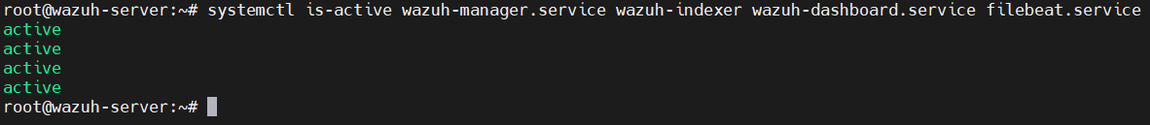

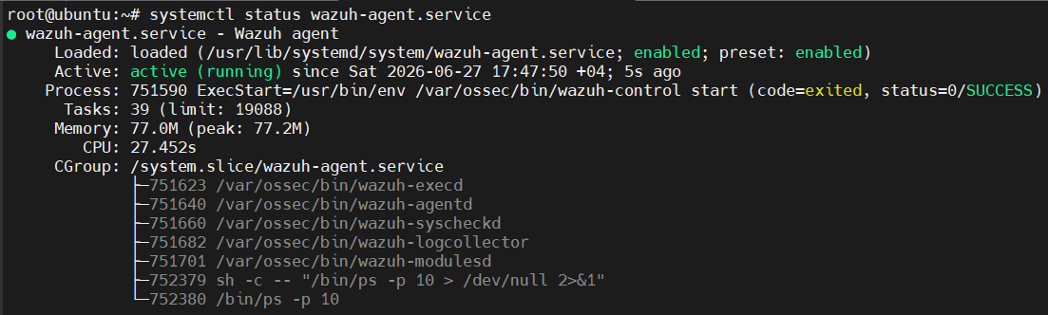
4 | Verify enrollment on the manager
Run on the Wazuh manager (<Wazuh_Manager_IP>):
/var/ossec/bin/agent_control -l

# Expected output:
# ID: 001 Name: <Agent_Name> IP: <Agent_IP> Status: Active

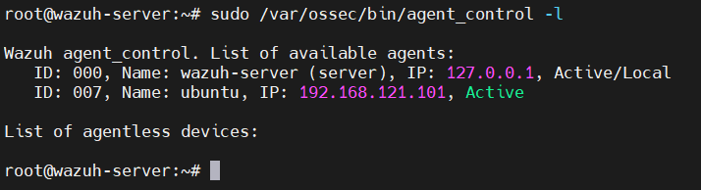

4. FIM — File Integrity Monitoring
FIM (syscheck) is Wazuh's core ransomware detection layer. It monitors file changes in real time, detecting mass renames, permission changes, and new files with suspicious extensions.

4.1 Configuration — /var/ossec/etc/ossec.conf (agent)
<syscheck>
<disabled>no</disabled>
<frequency>60</frequency> <!-- 60s for lab; use 600+ in production -->

<!-- Real-time monitoring on key directories -->
<directories check_all="yes" realtime="yes"
report_changes="yes">/home</directories>
<directories check_all="yes" realtime="yes"
report_changes="yes">/tmp/ransom_test</directories>
<directories check_all="yes" realtime="yes">/root</directories>
<directories check_all="yes" realtime="yes">/var/www</directories>

<alert_new_files>yes</alert_new_files>

<ignore>/proc</ignore>
<ignore>/sys</ignore>
<ignore>/dev</ignore>
</syscheck>

4.2 Apply the config
# On the agent
sudo systemctl restart wazuh-agent

# Verify FIM is active on the manager
sudo tail -f /var/ossec/logs/ossec.log | grep syscheck

5. Auditd Syscall Monitoring
Auditd captures kernel-level syscalls — mass renames, chmod operations, and file writes — that FIM alone cannot catch at the process level. Together they provide two independent detection layers.

5.1 Install and configure auditd (agent)
sudo apt install auditd audispd-plugins -y

5.2 Create ransomware audit rules
Create file /etc/audit/rules.d/ransomware.rules on the agent:

# Watch for mass file renames (ransomware encryption step)
-a always,exit -F arch=b64 -S rename -S renameat -k ransomware_rename

# Watch for mass file truncation (overwrite with encrypted content)
-a always,exit -F arch=b64 -S truncate -S ftruncate -k ransomware_truncate

# Watch home and tmp directories
-w /home -p wxa -k home_dir_watch
-w /tmp -p wxa -k tmp_dir_watch

# Watch mass chmod (pre-encryption permission changes)
-a always,exit -F arch=b64 -S chmod -S fchmod -k mass_chmod

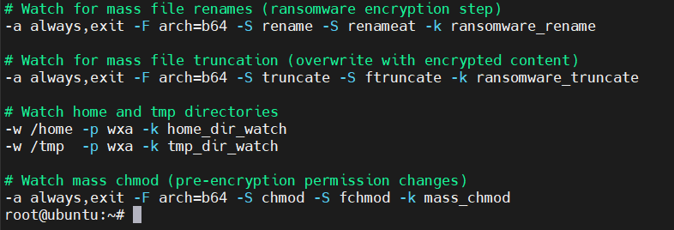

# Apply rules
sudo augenrules --load
sudo systemctl enable auditd --now

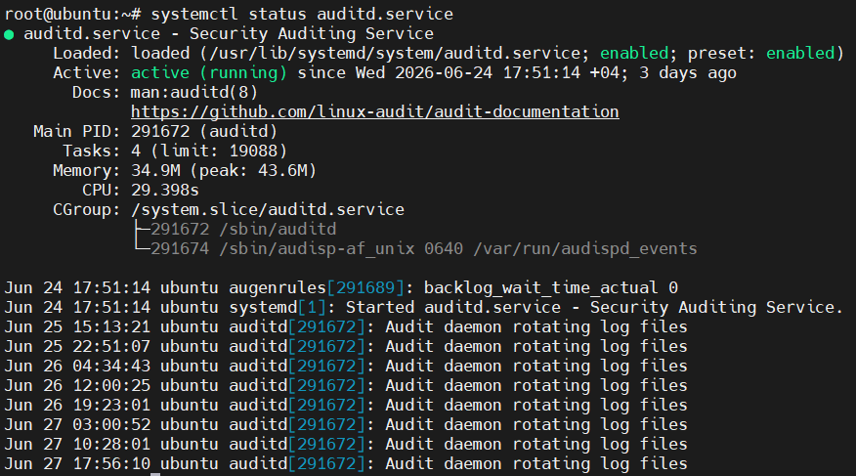
5.3 Connect auditd to Wazuh — ossec.conf (agent)
<localfile>
<log_format>audit</log_format>
<location>/var/log/audit/audit.log</location>
</localfile>

6. Custom Detection Rules
Create file /var/ossec/etc/rules/ransomware_detection.xml on the Wazuh manager. These rules fire when ransomware-like behavior is detected from FIM or auditd events.

<group name="ransomware,">

<!-- Suspicious file extension detected -->
<rule id="100200" level="12">
<if_group>syscheck</if_group>
<field name="file">.locked$|.encrypted$|.crypt$|.enc$|.WNCRY$</field>
<description>Ransomware: suspicious extension - $(file)</description>
<mitre><id>T1486</id></mitre>
</rule>

<!-- Mass file modifications (10+ files in 30 seconds) -->
<rule id="100201" level="14" frequency="10" timeframe="30">
<if_matched_group>syscheck</if_matched_group>
<same_field>agent.id</same_field>
<description>Ransomware: mass file modification (10+ in 30s)</description>
<mitre><id>T1486</id></mitre>
</rule>

<!-- New encrypted file created -->
<rule id="100202" level="12">
<if_sid>554</if_sid>
<field name="file">.locked$|.encrypted$|.enc$|.crypt$</field>
<description>Ransomware: new encrypted file created - $(file)</description>
<mitre><id>T1486</id></mitre>
</rule>

<!-- Ransom note dropped -->
<rule id="100203" level="15">
<if_group>syscheck</if_group>
<field name="file">README_DECRYPT|HOW_TO_DECRYPT|RANSOM_NOTE</field>
<description>Ransomware: ransom note detected - $(file)</description>
<mitre><id>T1486</id></mitre>
</rule>

<!-- Auditd: mass rename syscalls (20+ in 30s) -->
<rule id="100204" level="13" frequency="20" timeframe="30">
<if_matched_sid>80790</if_matched_sid>
<field name="audit.key">ransomware_rename</field>
<description>Ransomware: mass file rename via syscall</description>
<mitre><id>T1486</id></mitre>
</rule>

</group>

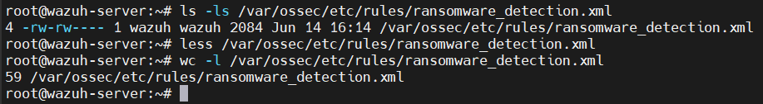
# Validate rules without restarting
sudo /var/ossec/bin/wazuh-analysisd -t

# Expected: wazuh-analysisd: INFO: (1243): A valid configuration was found.

7. Active Response Configuration
WARN | Every command name used in an <active-response> block MUST have a matching <command> definition block. Missing this causes error 1303 and the manager will not start.

7.1 Create custom kill-process script (manager)
Path: /var/ossec/active-response/bin/kill-process.sh

#!/bin/bash
LOG="/var/ossec/logs/active-responses.log"
NOW=$(date +"%Y/%m/%d %H:%M:%S")
ALERT_JSON=$(cat)

echo "$NOW - [kill-process] Triggered" >> "$LOG"

FILE_PATH=$(echo "$ALERT_JSON" | python3 -c "
import sys, json
try:
d = json.load(sys.stdin)
a = d.get('parameters',{}).get('alert',{})
print(a.get('syscheck',{}).get('path',''))
except: print('')
" 2>/dev/null)

if [ -n "$FILE_PATH" ] && [ -e "$FILE_PATH" ]; then
PIDS=$(fuser "$FILE_PATH" 2>/dev/null)
[ -n "$PIDS" ] && kill -9 $PIDS 2>/dev/null
echo "$NOW - Killed PIDs: $PIDS" >> "$LOG"
fi

# Kill simulation script if running
pkill -f ransom_sim.py 2>/dev/null
echo "$NOW - [kill-process] Done" >> "$LOG"
exit 0

sudo chmod 750 /var/ossec/active-response/bin/kill-process.sh
sudo chown root:wazuh /var/ossec/active-response/bin/kill-process.sh

INFO | The <active-response> blocks below use <location>local</location>, which means the command actually executes on the agent that generated the alert — not on the manager. The kill-process.sh script must therefore also exist on the Ubuntu agent, at the same path and with the same permissions, or the response will silently fail to run.

7.1b Deploy the script to the agent
Copy the identical script from the manager to the agent, at the same path, then apply the same ownership and permissions:
# From the manager, copy the script to the agent
scp /var/ossec/active-response/bin/kill-process.sh \
<Agent_IP>:/var/ossec/active-response/bin/kill-process.sh

# On the agent, set matching ownership and permissions
sudo chmod 750 /var/ossec/active-response/bin/kill-process.sh
sudo chown root:wazuh /var/ossec/active-response/bin/kill-process.sh
Note: firewall-drop is a built-in Wazuh Active Response script shipped with every agent install, so it needs no manual deployment — only kill-process.sh, since it is custom to this lab.
7.2 ossec.conf — command + active-response blocks (manager)
INFO | Place the <command> blocks BEFORE the <active-response> blocks, both inside the root <ossec_config> element.

<!-- ═══════════════════════════════════════ -->
<!-- COMMAND DEFINITIONS (required for all) -->
<!-- ═══════════════════════════════════════ -->

<command>
<name>firewall-drop</name>
<executable>firewall-drop</executable>
<timeout_allowed>yes</timeout_allowed>
</command>

<command>
<name>kill-process</name>
<executable>kill-process.sh</executable>
<timeout_allowed>yes</timeout_allowed>
</command>

<!-- ═══════════════════════════════════════ -->
<!-- ACTIVE RESPONSE TRIGGERS -->
<!-- ═══════════════════════════════════════ -->

<!-- Block network on ransomware detection -->
<active-response>
<command>firewall-drop</command>
<location>local</location>
<rules_id>100200,100201,100202,100203,100204</rules_id>
<timeout>3600</timeout>
</active-response>

<!-- Kill offending process -->
<active-response>
<command>kill-process</command>
<location>local</location>
<rules_id>100200,100201,100202,100203,100204</rules_id>
<timeout>60</timeout>
</active-response>

# Validate then restart
sudo /var/ossec/bin/wazuh-analysisd -t
sudo systemctl restart wazuh-manager
sudo systemctl status wazuh-manager

8. Ransomware Simulation & Testing
SAFE | ALL simulation tests run inside /tmp/ransom_test only. No real user data is touched. Run the cleanup command after every test.

Two simulation methods are provided below, each serving a different purpose. Use the Python simulator (8.1) for full validation of the lab: it creates a realistic file set, renames and rewrites each file with random ransomware-style extensions, and drops a ransom note — exercising all five detection rules (100200–100204) and giving Active Response a real process and file handle to act on. Use the quick shell test (8.2) only as a lightweight smoke test — for example, to confirm FIM and the mass-rename/ransom-note rules are wired up correctly after a config change — since it runs and exits in under a minute and does not keep a process attached to the encrypted files for Active Response to terminate.
8.1 Python ransomware simulator (recommended)
Save as /tmp/ransom_sim.py on the Ubuntu agent:

#!/usr/bin/env python3
import os, time, random

TEST_DIR = "/tmp/ransom_test"
EXTS = [".locked", ".encrypted", ".enc", ".crypt"]

def create_files(n=30):
os.makedirs(TEST_DIR, exist_ok=True)
for i in range(n):
with open(f"{TEST_DIR}/document_{i:03d}.txt", "w") as f:
f.write(f"Sensitive data {i}\n" * 10)
print(f"[*] Created {n} test files")

def simulate():
files = [f for f in os.listdir(TEST_DIR) if f.endswith(".txt")]
for fname in files:
old = os.path.join(TEST_DIR, fname)
new = os.path.join(TEST_DIR, fname.replace(".txt", random.choice(EXTS)))
os.rename(old, new)
with open(new, "wb") as f: f.write(os.urandom(512))
print(f"[*] Encrypted: {fname}")
time.sleep(0.1)
# Drop ransom note
with open(f"{TEST_DIR}/README_DECRYPT.txt", "w") as f:
f.write("YOUR FILES ENCRYPTED - Wazuh test only\n")
print("[!] Ransom note dropped. Check Wazuh dashboard.")

import sys
if len(sys.argv) > 1 and sys.argv[1] == "cleanup":
import shutil; shutil.rmtree(TEST_DIR, ignore_errors=True); print("[*] Cleaned.")
else:
create_files(30); time.sleep(2); simulate()

# Run simulation
python3 /tmp/ransom_sim.py

# Cleanup
python3 /tmp/ransom_sim.py cleanup

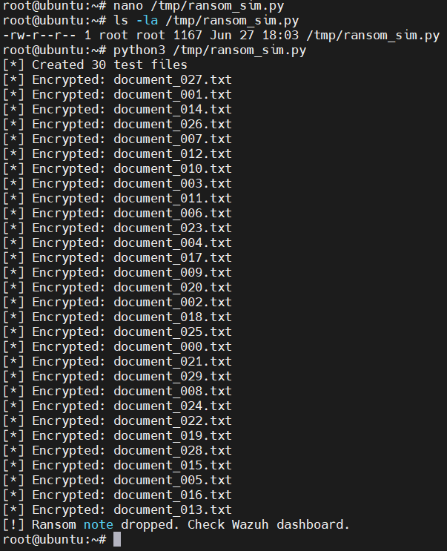
8.2 Quick shell test (1 minute)
mkdir -p /tmp/ransom_test

# Create 20 dummy files
for i in $(seq 1 20); do
echo "data $i" > /tmp/ransom_test/file_$i.txt
done

# Mass rename to encrypted extensions
for f in /tmp/ransom_test/*.txt; do
mv "$f" "${f%.txt}.locked"
sleep 0.2
done

# Drop ransom note
echo "RANSOM" > /tmp/ransom_test/README_DECRYPT.txt

# Cleanup
rm -rf /tmp/ransom_test

9. Real-time Alert Monitoring
Open two additional terminal windows on the manager before running any simulation. One watches raw alerts, one watches active response actions.

9.1 Watch all alerts in real time
sudo tail -f /var/ossec/logs/alerts/alerts.json | python3 -m json.tool 2>/dev/null

9.2 Filter for ransomware rules only
sudo tail -f /var/ossec/logs/alerts/alerts.json | python3 -c "
import sys, json
RULES = {'100200','100201','100202','100203','100204'}
for line in sys.stdin:
try:
a = json.loads(line)
rid = str(a.get('rule',{}).get('id',''))
if rid in RULES:
print(f\"[RANSOMWARE] Rule {rid} Level {a['rule']['level']}\")
print(f\" Desc : {a['rule']['description']}\")
print(f\" File : {a.get('syscheck',{}).get('path','N/A')}\")
print()
except: pass
"

9.3 Watch active response actions
sudo tail -f /var/ossec/logs/active-responses.log

9.4 Confirming Active Response execution
A ransomware alert on its own only proves detection. Watching /var/ossec/logs/active-responses.log during the Python simulation (8.1) confirms the response itself actually ran. Expected output on the agent for kill-process:
# kill-process.sh entries (custom AR)
2026/06/09 10:15:22 - [kill-process] Triggered
2026/06/09 10:15:22 - Killed PIDs: 48213
2026/06/09 10:15:22 - [kill-process] Done

# firewall-drop entries (built-in AR)
2026/06/09 10:15:22 ar-log: Starting
2026/06/09 10:15:22 ar-log: firewall-drop: Blocking <Agent_IP>
2026/06/09 10:15:22 ar-log: Ended
On the manager side, /var/ossec/logs/ossec.log will additionally show an "Active response command executed" line referencing the same rule ID and agent. If active-responses.log stays empty while alerts.json keeps showing matches, revisit the Troubleshooting Reference entry for "AR not firing" — the most common cause at this stage is the script not yet being present on the agent (see 7.1b).
9.5 Wazuh dashboard
URL: https://<Wazuh_Dashboard_IP> (port 443)
Navigate to: Security Events → filter by rule.groups: ransomware

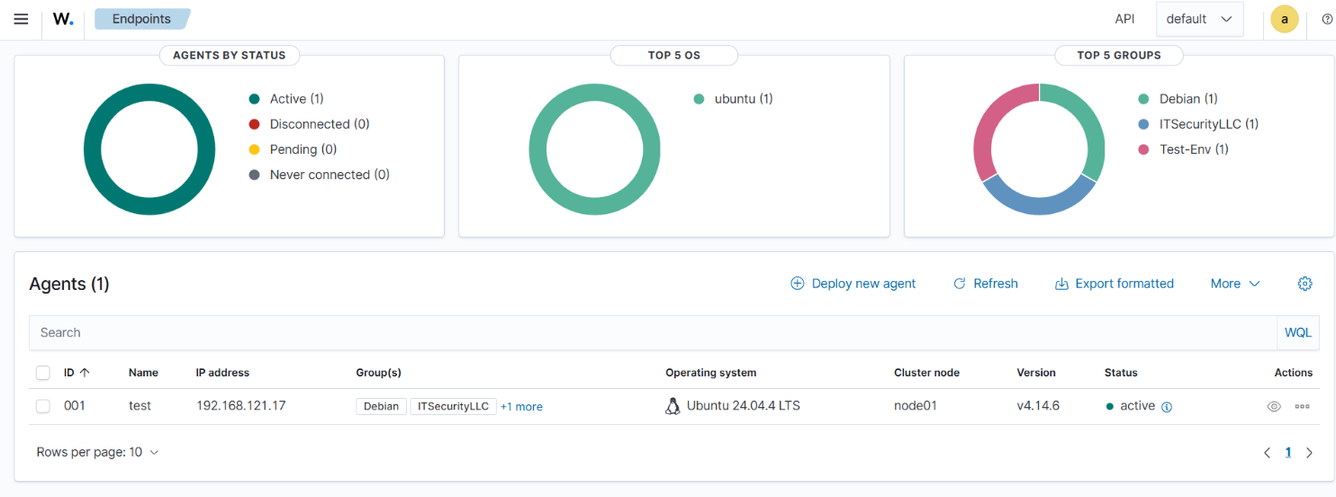

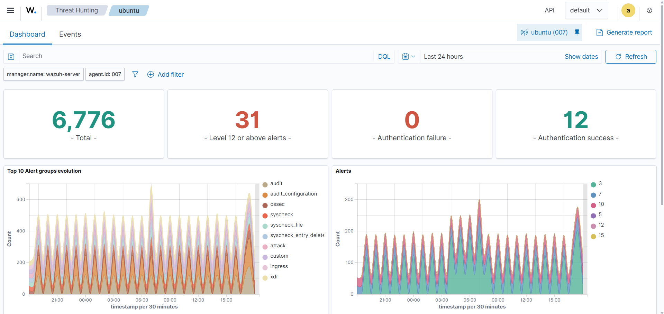
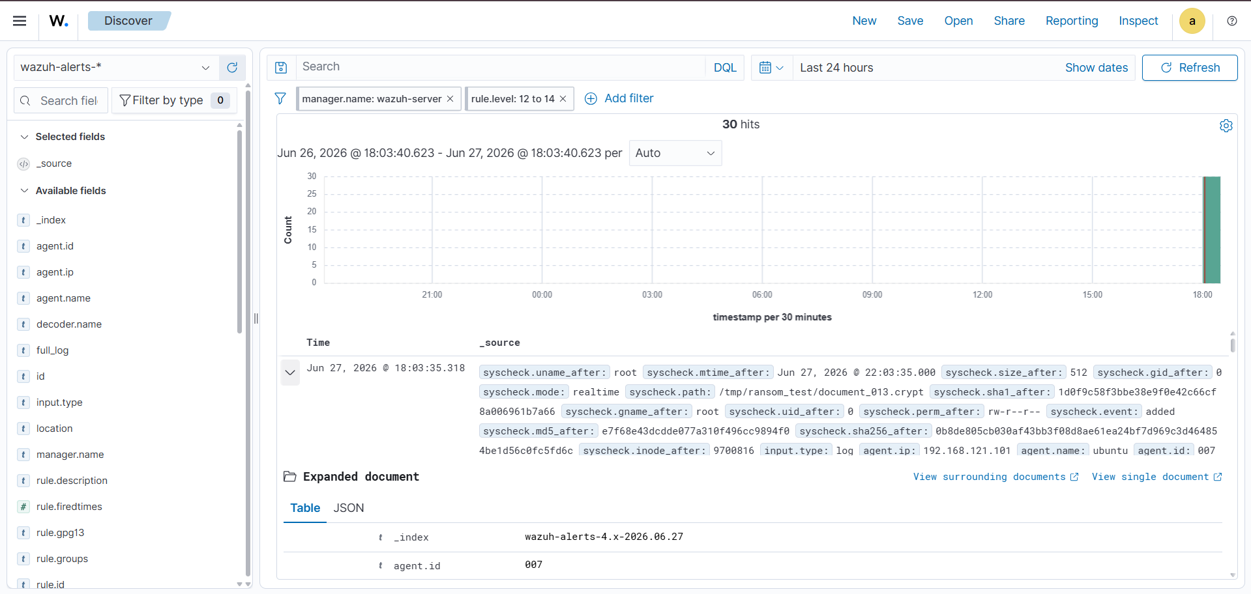

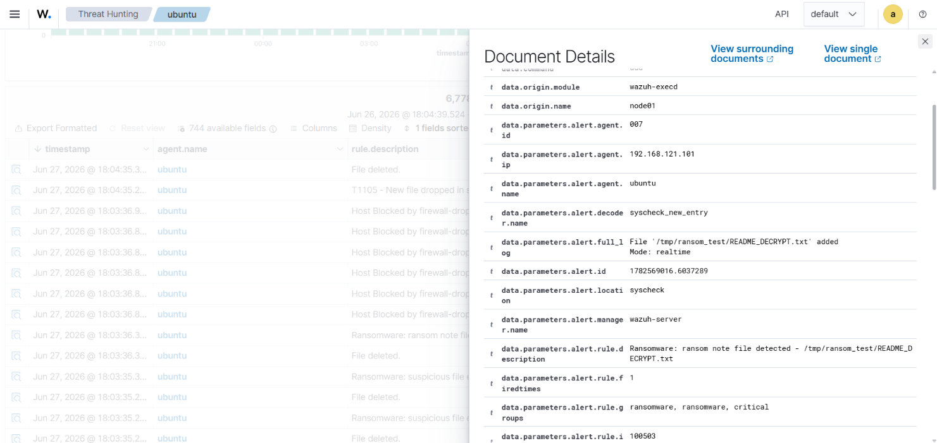

10. Troubleshooting Reference

Error / Symptom | Root cause | Fix
Error 1303: Invalid command | Command in <active-response> has no <command> definition | Add <command> block for every AR command before <active-response>
Error 1202: Config error | XML syntax error or logic error in ossec.conf | Run: /var/ossec/bin/wazuh-analysisd -t
Manager fails to start | Any CRITICAL error in analysisd | Check: journalctl -xeu wazuh-manager.service
Agent shows Disconnected | Port 1514 blocked between agent and manager | Open TCP 1514 from <Agent_IP> to <Wazuh_Manager_IP>
No alerts in dashboard | FIM disabled or wrong directory path | Verify <syscheck> block; ensure realtime=yes
AR not firing | Rule level too low or wrong rule ID in AR config | Check rules_id and level values match your custom rules
kill-process.sh not running | Wrong permissions or not owned by root:wazuh | chmod 750 and chown root:wazuh on the script
FIM too slow to detect | frequency set too high | Set <frequency>60</frequency> for lab testing

wazuh. Ransomware Detection Lab Guide | Community Edition | https://wazuh.com
All Wazuh trademarks and logos are property of Wazuh Inc. This document is for community and educational use.

